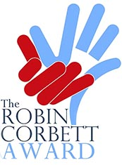

The Robin Corbett Award for Prisoner Re-integration

Application form for 2020 Awards

Please note applications must be signed by a prison governor OR a senior executive OR a director. This shows the judges that he/she knows your work and validates it.

- Signature and title of person endorsing your nomination (also print the name)

- Places where you are working?

- Statement of governor/director/senior manager setting out the contribution that the charity, not-for-profit or social enterprise makes to prisoner re-integration

---------------------------------------------------------------------------------------------------------------------
Nominated charity or not for profit body:

- Legal name of charity or not-for-profit body:

- Charity number (if applicable):

- Name, role, telephone number and email address of primary contact person in nominated organisation:

- From the most recent annual accounts, (year ended: March 2019) please tell us the total:

Income: £ Expenditure: £ Unrestricted reserves: £

- Describe the work which you are nominating for an award (100 words max)

- How does your work contribute to prisoners being able to re-integrate in society after release? (350 words max)

- How does your work help prisoners to take responsibility for themselves and to help others? (250 words max)

- What is the evidence of your work succeeding?

- From prisoners, during and/or after custody
- From other sources
(250 words max)

- How would you use the prize money and the profile that comes with the Award?
(max 100 words)

Closing date for nominations: Monday 9th December 2019

Please email to info@robincorbettaward.co.uk

Or post: Robin Corbett Awards, P. O. Box 41 Cheltenham GL54 1XZ

If there are any questions: 07762099425

